# Project Report on

COVID'19 Analysis Using

IBM Cognos Dashboard

Submitted by:

**Team ECE-016**

Bathini Harini (19R11A04E6)

Beeram Ankitha Manisri (19R11A04E7)

Bhumpalli Manichandan Reddy (19R11A04E8)

Bisadi Ramyasri (19R11A04E9)

Cheerla Akshitha (19R11A04F0)

Under The Guidance of :

**Ms. Pradeepthi**

**SMARTINTERNZ**

**8 June,2021**



**Department of Electronics and Communications Engineering**

***Geethanjali College of Engineering and Technology***

|  |
| --- |
|  |

1. INTRODUCTION
   * OVERVIEW

The first outbreak of COVID'19(known to cause respiratory infections) was in Wuhan, China in the month of December. The first case to be identified in India was not until late days of January,2020.

In our project we would be analysing the spread of the coronavirus throughout the country from 30th January,2020 to 16th of april,2020.

* + PURPOSE

> Understand the concepts and work on IBM Cognos Analytics.

> Learn to plot different graphs and create visualizations using the dataset.

> Create easy and understandable dashboards.

> Get the most insights of COVID'19 in India.

2)LITERATURE SURVEY

* + EXISTING PROBLEM

**Coronavirus disease 2019** (**COVID-19**) is a [contagious disease](https://en.wikipedia.org/wiki/Contagious_disease) caused by [severe acute respiratory syndrome coronavirus 2](https://en.wikipedia.org/wiki/Severe_acute_respiratory_syndrome_coronavirus_2) (SARS-CoV-2). The first known case was identified in [Wuhan](https://en.wikipedia.org/wiki/Wuhan), [China](https://en.wikipedia.org/wiki/China) in December [2019](https://en.wikipedia.org/wiki/2019). The disease has since spread worldwide, leading to an [ongoing pandemic](https://en.wikipedia.org/wiki/COVID-19_pandemic).

[Symptoms of COVID-19](https://en.wikipedia.org/wiki/Symptoms_of_COVID-19) are variable, but often include fever, cough, headache, fatigue, [breathing difficulties](https://en.wikipedia.org/wiki/Breathing_difficulties), and [loss of smell](https://en.wikipedia.org/wiki/Anosmia) and [taste](https://en.wikipedia.org/wiki/Ageusia). Symptoms may begin one to fourteen days [after exposure](https://en.wikipedia.org/wiki/Incubation_period) to the virus. [Older people](https://en.wikipedia.org/wiki/Older_people) are at a higher risk of developing severe symptoms. Some people continue to experience a range of effects ([long COVID](https://en.wikipedia.org/wiki/Long_COVID)) for months after recovery, and damage to organs has been observed. Multi-year studies are underway to further investigate the long-term effects of the disease.

[Transmission of COVID-19](https://en.wikipedia.org/wiki/Transmission_of_COVID-19) occurs when people are exposed to virus-containing [respiratory droplets](https://en.wikipedia.org/wiki/Respiratory_droplet) and [airborne](https://en.wikipedia.org/wiki/Airborne_transmission) particles exhaled by an infected person. Those particles may be inhaled or may reach the mouth, nose, or eyes of a person through touching or direct deposition (i.e. being coughed on). The risk of infection is highest when people are in close proximity for a long time, but particles can be inhaled over longer distances, particularly indoors in poorly ventilated and crowded spaces. In those conditions small particles can remain suspended in the air for minutes to hours. Touching a [contaminated surface or object](https://en.wikipedia.org/wiki/Fomite) may lead to infection although this does not contribute substantially to transmission. People who are infected can transmit the virus to another person up to two days before they themselves show symptoms, as can people who do not experience symptoms. People remain infectious for up to ten days after the onset of symptoms in moderate cases and up to twenty days in severe cases.

Several [testing methods](https://en.wikipedia.org/wiki/COVID-19_testing) have been developed to diagnose the disease. The standard diagnostic method is by detection of the virus' [nucleic acid](https://en.wikipedia.org/wiki/Nucleic_acid) by [real-time reverse transcription polymerase chain reaction](https://en.wikipedia.org/wiki/Reverse_transcription_polymerase_chain_reaction) ,[transcription-mediated amplification](https://en.wikipedia.org/wiki/Transcription-mediated_amplification) (TMA), or by [reverse transcription loop-mediated isothermal amplification](https://en.wikipedia.org/wiki/Reverse_transcription_loop-mediated_isothermal_amplification) (RT-LAMP) from a [nasopharyngeal swab](https://en.wikipedia.org/wiki/Nasopharyngeal_swab).

[Preventive measures](https://en.wikipedia.org/wiki/Pandemic_prevention) include [physical or social distancing](https://en.wikipedia.org/wiki/Social_distancing), [quarantining](https://en.wikipedia.org/wiki/Quarantine), ventilation of indoor spaces, covering coughs and sneezes, [hand washing](https://en.wikipedia.org/wiki/Hand_washing), and keeping unwashed hands away from the face. The [use of face masks or coverings](https://en.wikipedia.org/wiki/Face_masks_during_the_COVID-19_pandemic) has been recommended in public settings to minimize the risk of transmissions. Several [vaccines](https://en.wikipedia.org/wiki/COVID-19_vaccine) have been developed and many countries have initiated mass vaccination campaigns.

Although work is underway to [develop drugs](https://en.wikipedia.org/wiki/COVID-19_drug_development) that inhibit the virus, the primary [treatment](https://en.wikipedia.org/wiki/Treatment_and_management_of_COVID-19) is symptomatic. Management involves the [treatment of symptoms](https://en.wikipedia.org/wiki/Palliative_care), [supportive care](https://en.wikipedia.org/wiki/Symptomatic_treatment), [isolation](https://en.wikipedia.org/wiki/Isolation_(health_care)), and [experimental measures](https://en.wikipedia.org/wiki/Medical_research).

The COVID-19 health crisis is like an ever-rising tide, testing patience, energy, and forcing people to distance themselves from their day-to-day social routines. The global emergency is changing the way we work, but it is also telling us something about what work means to our communities and us.

We as a nation can fight back in such situations with proper analysis and providing facilities according to the outcomes.

* + PROPOSED SOLUTION

By using the IBM Cognos Analytics we can have a clear insights about COVID'19 in India.

IBM Cognos Business Intelligence is a web based reporting and analytic tool. IT is used to perform data aggregation and crate user friendly detailed reports. Reports can contain graphs, multiple pages, different tabs which will help us understand our data easily. Cognos also provides you an option to export the report in XML or PDF format.

3)THEORITICAL ANALYSIS

* + BLOCK DIAGRAM

Covid-19 Analysis using IBM Cognos Dashboard

Collection of Data set

Creating Visualizations using Cognos analytics

Creating a meaningful Dashboard

Exporting the Analysis

* + HARDWARE/SOFTWARE DESIGNING

1)Solution Requirements

**Service Used:**IBM Cognos Analytics.

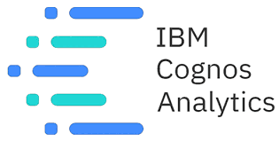

4) EXPERIMENTAL INVESTIGATIONS

To create the Visualizations we gather together a Dataset

This project is based on understanding COVID 19 in India.

The dataset has 1,025 data points (rows) and 8 features (columns) describing the results of Covid (confirmed cases, cured cases, death cases etc.)  related details

Let’s understand the data we’re working with and give a brief overview of what each feature represents or should represent

1. Date- gives us the dates on which case analysis(deaths, cured, confirmed) are seen in every state
2. Time- represents at which time the information is updated
3. State/ Union Territory- the states in India
4. Confirmed Indian National- Cases Confirmed in India
5. Confirmed Foreign National- Cases Confirmed Apart From India(Foreign)
6. Cured- No: of Cured Cases (Cumulative field)
7. Deaths- No: of Deaths (Cumulative field)
8. Confirmed- No: of Confirmed Cases (Cumulative field)

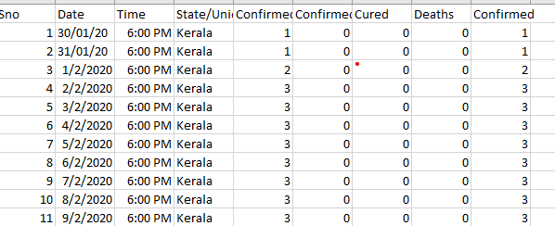

5)FLOWCHART

To accomplish this, we have to complete all the activities and tasks listed below

Login to Cognos Analytics

Working with Dataset

(understand and Loading the Dataset)

Data Visualization Charts

Statistics of choosen state

(Bar graph)

Monthly Analysis

(Line graph)

Top 10 state wise no. of confirmed cases

(Bar graph)

Covid 19 India Statistics

(Map)

Percentage of confirmed cases of top 10 affected states

(Pie-chart)

Dashboard Creation

6)RESULT

Created a informative dashboard using IBM Cognos analytics and got clear insights over COVID'19 in India.

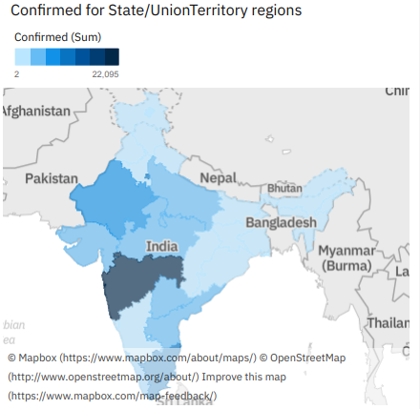

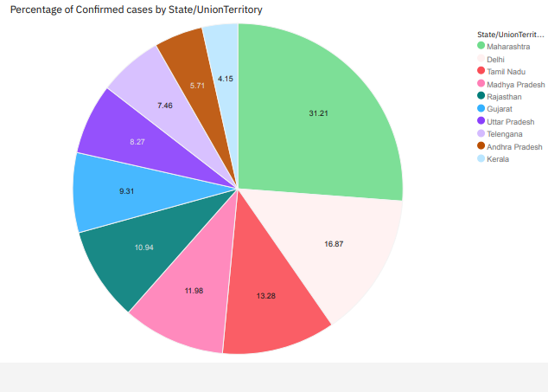

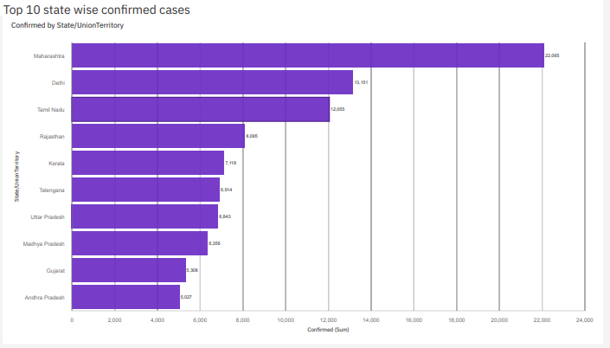

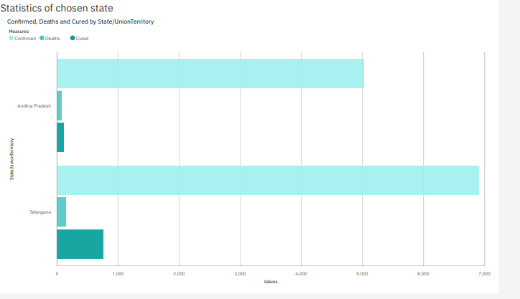

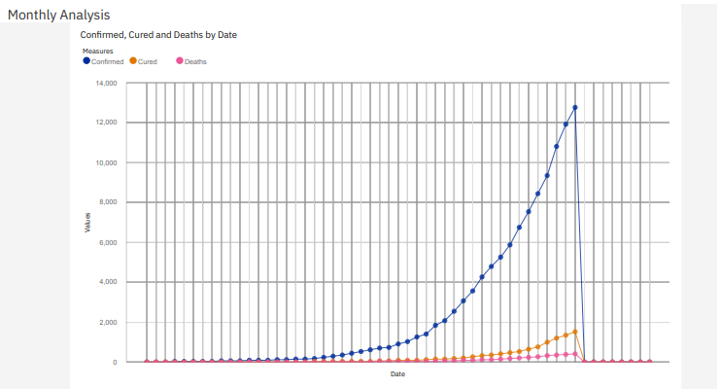

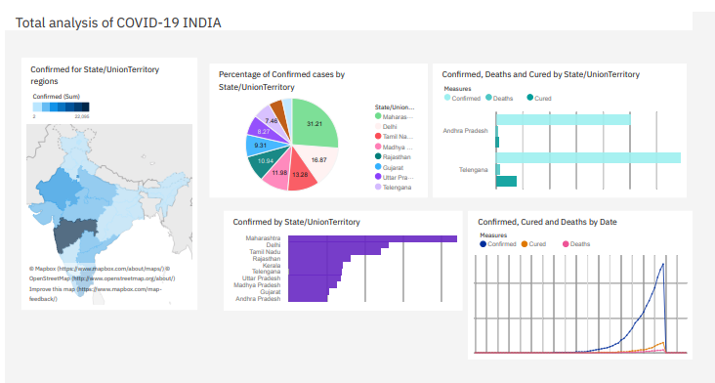

7)ADVANTAGES & DISADVANTAGES

> Now we have better understanding about the COVID'19 crisis in India.

> Easier to understand and analyse with the help of the dashboard created.

> The software used was easy to use hence helped us create visualizations quickly.

> The analysis done is not up to date hence needed to be updated quite often.

8)APPLICATIONS

The analysis done can be used to understand the severity of each state across the country. This helps in sending required facilities and needs to the most affected areas and alert the least affected areas to stay safe. Also brings out awareness to the people about the crisis.

9)CONCLUSION

By Now, We have already understood that Covid-19 is not just a disease which prevails only for few months. As it’s been almost more than 18 months since the pandemic stroked our lives and it’s no surprise it’ll remain longer.

So, the biggest challenge ahead us is to – Tackle all the hardships and prepare ourselves for coming days. Before this, we need to analyse the situation (i.e, Data) to solve this problem.

And Analysing the data is the prime option. But, analysing such huge loads of data is not easy which makes this problem even more complex.

At this very stage, Data Visualizations comes into picture. Visualizations such as maps, pie-charts, bar graphs, line graph makes this process much simpler. Also, it helps us understand the data to a greater extent.

Data Visualizations can be prepared with the help of existing Data sets, which in return makes everyone understand the data thus creating a pathway to create new ideas that would help us to fight against the pandemic.

For instance, by analysing the number of newly registered covid cases, effect on teens and death rate, one can understand the intensity of virus spread and thus decisions regarding - lockdown, Disclosure of Educational Institutions, Vaccine supply and Hospital facilities will be made clearly.

To conclude, we have understood that analysing the data is the major solution and data visualizations are the set of analytics which helps us face this challenge efficiently.

10)FUTURE SCOPE

The spread of the COVID-19 global pandemic has generated an exponentially mounting and extraordinary volume of data that can be harnessed to improve our understanding in the view of pandemic and measures to be taken.

This project will help in predictive analysis in the future. Predictive analysis concerns on what will happen in future and this comprises of clear understanding of current and historical facts to predict and solve the issues that may occur in future accordingly.

For example, the given formulae for visualizations could be helpful even in the future with just a minimal change in the number. And data in this project could add value for many articles, researches and so on.

Also, This data analysis, if studied and compared helps in providing valuable insights in regard of calculating rate of Improvement (i.e., if we could look at a state, studying its rate of virus spread and recovery rate, then comparing it with the future’s analytics gives us the difference that particular state made from that of others and also the measures taken can be recorded).

Most importantly this data analysis helps our next generations to face further outbreaks of Covid-19 and also any pandemic of this kind in the coming future. Hence, Enhancing a Better Tomorrow.

11)BIBLIOGRAPHY

Learnt about IBM Cognos Analytics from SmartInternz website.

Gathered information about COVID'19 from the following links:

> https://covid19.who.int/

> https://en.wikipedia.org/wiki/COVID-19_pandemic_in_India

Thank You..